**LAB # 08**

**Task #1: Create an application which can manipulate a Clock object having hours, minutes and seconds as integer attributes. Your application must have only two activities as follows:**

* 1. ***ClockActivity:***

**Shows the clock contents and the gives field selection by radio buttons for update. Creates new Clock object, displays it and send it to UpdateActivity for update.**

* 1. ***UpdateActivity:***

**Gets data for the selected field. Saves the field in the object and send back object to ClockActivity.**

**Solution:**

**Design:**

**Activity_clock**

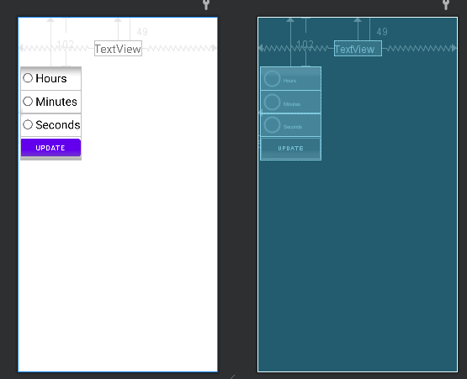

**Activity_update:**

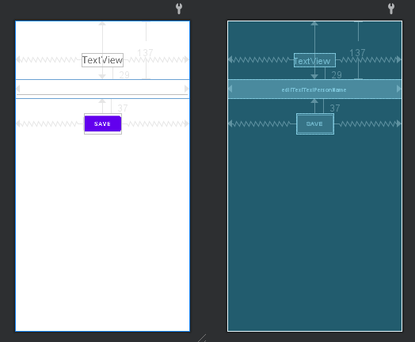

**Code:**

**Time_class:**

public class TimeClass implements Serializable {

private int hours,min,sec;

TimeClass(int h,int m,int s){

this.hours=h;

this.min=m;

this.sec=s;

}

public void setHours(int h){

this.hours=h;

}

public void setMin(int m){

this.min=m;

}

public void setSec(int s){

this.sec=s;

}

public int getHours(){

return this.hours;

}

public int getMin(){

return this.min;

}

public int getSec(){

return this.sec;

}

public String getTime(){

return ""+hours+":"+min+":"+sec;

}

}

**Clock_Activity:**

public class ClockActivity extends AppCompatActivity {

private RadioGroup radioGroup;

private RadioButton radioButton1;

private RadioButton radioButton2;

private RadioButton radioButton3;

private Button button;

private TextView textView;

private TimeClass t;

@Override

protected void onCreate(Bundle savedInstanceState) {

super.onCreate(savedInstanceState);

setContentView(R.layout.activity_clock);

radioGroup=findViewById(R.id.radioGroup);

radioButton1=findViewById(R.id.radioButton);

radioButton2=findViewById(R.id.radioButton2);

radioButton3=findViewById(R.id.radioButton4);

button=findViewById(R.id.button);

textView=findViewById(R.id.textView2);

Intent intent=new Intent(this,UpdateActivity.class);

Bundle bundle=new Bundle();

t=new TimeClass(12,45,45);

textView.setText(t.getTime());

button.setOnClickListener(new View.OnClickListener() {

@Override

public void onClick(View view) {

if(radioButton1.isChecked()){

bundle.putSerializable("timeClass",t);

bundle.putString("hint","Enter Hours");

} else if (radioButton2.isChecked()) {

bundle.putSerializable("timeClass",t);

bundle.putString("hint","Enter Minutes");

} else if (radioButton3.isChecked()) {

bundle.putSerializable("timeClass",t);

bundle.putString("hint","Enter Seconds");

}

intent.putExtra("Bundle_Data",bundle);

startActivityForResult(intent,1);

}

});

}

@Override

protected void onActivityResult(int requestCode, int resultCode, Intent data) {

super.onActivityResult(requestCode, resultCode, data);

if (requestCode == 1 && resultCode == RESULT_OK) {

TimeClass updatedTime = (TimeClass) data.getSerializableExtra("updatedTime");

textView.setText(updatedTime.getTime());

t.setMin(updatedTime.getMin());

t.setSec(updatedTime.getSec());

t.setHours(updatedTime.getHours());

}

}

}

**Update_Activity:**

public class UpdateActivity extends AppCompatActivity {

private EditText editText;

private Button button;

private TextView textView;

@SuppressLint("MissingInflatedId")

@Override

protected void onCreate(Bundle savedInstanceState) {

super.onCreate(savedInstanceState);

setContentView(R.layout.activity_update);

try {

editText=findViewById(R.id.editTextTextPersonName);

button=findViewById(R.id.button2);

textView=findViewById(R.id.textView);

Intent intent=getIntent();

Bundle bundle=intent.getBundleExtra("Bundle_Data");

String hint=bundle.getString("hint");

TimeClass t = (TimeClass) bundle.getSerializable("timeClass");

textView.setText(hint);

button.setOnClickListener(new View.OnClickListener() {

@Override

public void onClick(View view) {

String val=editText.getText().toString();

if(hint.equals("Enter Hours")){

t.setHours(Integer.parseInt(val));

}

else if (hint.equals("Enter Minutes")) {

t.setMin(Integer.parseInt(val));

} else if (hint.equals("Enter Seconds")) {

t.setSec(Integer.parseInt(val));

}

Log.d("UpdateActivity", "Updated time: " + t.getTime());

Intent returnIntent = new Intent();

returnIntent.putExtra("updatedTime", t);

setResult(RESULT_OK, returnIntent);

Log.d("UpdateActivity", "Set result: RESULT_OK");

finish();

}

});

} catch (Exception e) {

Log.e("UpdateActivity", "Error: " + e.getMessage());

}

}

}

**Output:**

